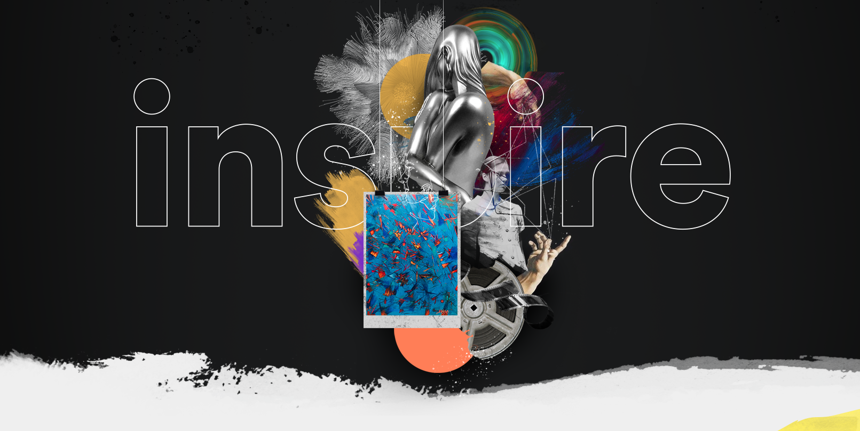

INSPIRE Miami 2019
www.inspire-miami.com

A
Ralwins Art Gallery
Production

23 E. Oglethorpe Street
Ellaville, GA 31806
www.RalwinsArtGallery.com
229.314.2882

INSPIRE AT A GLANCE

Ralwins Art Gallery is proud to present our first annual INSPIRE Miami 2019, consisting of visual arts, fashion and cinema.
INSPIRE will be hosted in the Ampersand Studios building located in the Miami Design District during the Miami Art Week, commonly known as the Art Basel in the U.S. INSPIRE is the only event presenting a fusion of creative minds among the biggest names of the Miami Design District community in art, architecture and fashion.
Ralwins Art Gallery was created three years ago and its participation during this Art Week in Miami has been the launch-pad for its explosive growth, not only in the number of participating exhibitors, but also with clients and followers from social media, allowing us to expand to other zones as New York City and New Mexico.
We have a mailing list of over 10,000 subscribers to our newsletter. We do a massive social media campaign focusing on Facebook and Instagram for our events. Marketing to the Spanish and English speaking audience, we have a strong presence in the Colombian, Cuban, Dominican and Mexican communities in Miami. This assures our patrons and sponsors that we will have great coverage and attendance in the city of Miami, where 70% of the community is Hispanic. According to our survey, 80% of our attendees are probably your clients or your current marketing targets. INSPIRE is an opportunity to showcase your product or service to a large audience and increase your market share.

Goals & Objectives
INSPIRE is a platform for Independent Artists to showcase themselves in the art industry during the largest art gathering in America, Miami Art Week | Art Basel Week. Our artists are well-known in their home countries and are now seeking the same opportunity in the US, by bringing us their latest creations. With the fusion of Visual Art, Fashion and Cinema, we aim to stand out amongst all the fabulous events taking place during the Miami Art Week.

Engage With Our Audience
62%  Female |  | 38%  Male |  | 51%  Annual household income in excess of $100,000
70%  Hispanic Heritage | 63%  18–49 years of age |  | 72%  S. Florida Residents | 77%  More opportunity to do business with brands that support the arts.

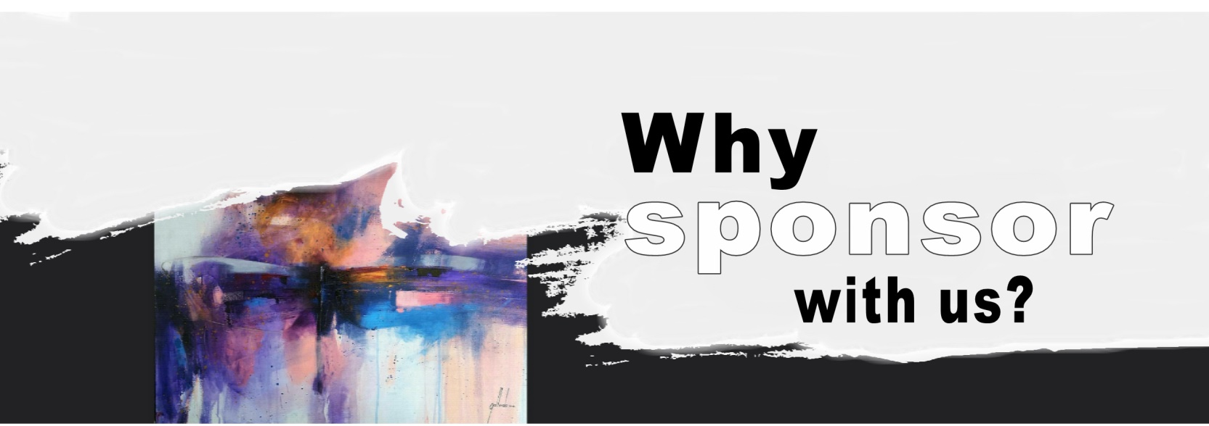

INSPIRE showcases talented independent artists with a gateway to Latin America that fosters Arts, Fashion and Short Films. The 5-day event offers an abundance of opportunities to promote your brand and by supporting us; you join an elite group of brands that support independent artists.
- To increase prospective consumers attending the 5-days event.
- To market/launch new products/services.
- To reach a wider audience and secure new customers in Miami and elsewhere.
- To establish networking relationships within the Miami community.
- To produce a memorable customer experience that conveys your brand image domestically and internationally.

Proposal

Our promotion began with the launch of the event website in July 2019. Sponsors will benefit from a 9 month marketing strategy where advertising will occur, 5 months pre-event, and approximately 4 months post-event.
At INSPIRE Miami 2019, we believe that a successful event combines our creative strength with the strategy and in-depth knowledge of our clients and sponsors. Our event provides the artists and sponsors with the marketing results they are looking for. Our marketing campaign consists of an event catalog (printed and online) free to all attendees, a strong media presence (radio, television and newspaper), strong social media advertising (Instagram, Facebook, Linked-in, Google, etc.), our newsletter; to keep the public up to date with the event, along with YouTube. During the event we will continue promoting our sponsors in our large cinema screen.

Sponsorship Benefits
ON-SITE ACTIVATIONS  Create an audience experience with product integration and sampling at one of our Short Film screenings, parties, runaways or daily event hours. | NAMING RIGHTS  Opportunity to name a film competition, category, and/or award that will be internationally recognized with the Event’s official selection.
DIGITAL AND SOCIAL MEDIA  Direct traffic to your site by placing an ad on our digital platforms. Offerings include weekly newsletter with 10k subscribers or Event’s main site. With fans and followers on social media platforms offer a highly visible opportunity to promote your brand. | GIFTING  Put your product in the hands of the Event’s audience or VIP guests through a variety of product placement opportunities available in exclusive and non-exclusive categories.
LOGO PLACEMENT  Align your brand through various digital and printed platforms. From step and repeats to on-screen experiences, give your logo awareness & visibility among local, national, and international audiences. Logos can be included on the Short Film trailer which plays before each movie screening. Logos are displayed in the Event’s Ticket Program where readers can learn everything about the Event and in the Event catalogue. | YOUR CUSTOM IDEA  We work intimately with each brand to create unique, customized experiences. Give us your ideas and we can make it happen.

Sponsorship Packages
We have come a long way, but we still need your support. Your generous contribution will help us extend our Independent Artist's Platform to a much larger audience by your participation and support in our marketing campaign.
 | GOLD | SILVER | BRONCE
Naming rights to event live plugs in opening and closing speech | X
Logo on ALL printed materials | X
30 second company promo played on the cinema screen | X must provide
Short promo video for insertion in event web-page | X must provide
Promo image with link for insertion in event web-page | X | X
Company mention on all media outlets (tv/radio) | X | X
Banner display on the outside perimeter during the event | 4'x6' | 2'x4'
Within the event presence (space base on agreement) | X | X
Ad in printed catalog | 1 full page | 1/2 page | Logo
Logo on event printed program | X | X | X
Logo on the Red Carpet Wall | X | X | X
Regular event admission ticket (qty.) | 100 | 50 | 25
VIP passes to opening reception (qty.) | 40 | 20 | 10
Logo on all digital material | X | X | X
Linkable logo on event web-page | X | X | X
Logo in newsletter | X | X | X
Logo on all media (television and videos) presentation | X | X | X
Ad in digital catalog | 1 page | 1/2 page | 1/4 page
Promotional gifts hands out /insertion in event give away tote bag. | X must provide | X must provide | X must provide
Value of Sponsorship | $10,000 | $6,000 | $3,500
Contact us today to discuss opportunities for your brand or if you have any queries about this proposal, please feel free to reach out to us at any time 229.314.2882.

